IP CABLING TRANSMISSION – POE Repeater
ITEM NO.: IP04X High Power POE Repeater

IP04X is a High Power POE repeater to extend power and data an additional 100meters. Multiple units are allowed for longer distance, eliminating the need for additional switches, hubs and expensive fiber installations. It compliant with standard POE IEEE802.3af and IEEE802.at
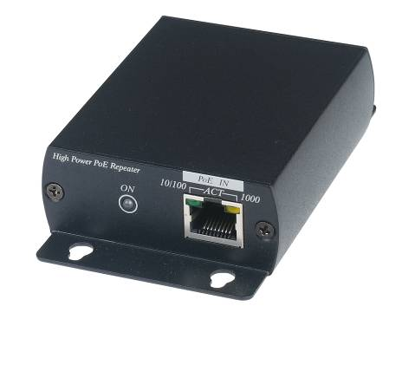
IP04X High Power POE Repeater
- Extend of both power and data beyond 100 meters.
- Allow to use multiple repeaters for longer range.
- No external power required.
- Compatible IEEE802.af and IEEE 802.3at POE standard.
- Auto-sensing for detecting PoE or non-PoE devices.
- Support 10/100/1000 BASE-T transmission rate.
- Built in LED status indication.
- Perfect for long range outdoor POE camera use.
- Plug and play for easy installation.

Installation View:

IP04X itself provide data and power 120 meters，the power will drop as below by multiple POE repeaters and long cable length application:

Max Device Power Range with PoE switch | 1st IP04X Max. | 2nd IP04X Max. | 3rd IP04X Max.
Max Device Power Range with PoE switch | 18.84W at 240M | 12.18W at 360M | 5.52W at 480M

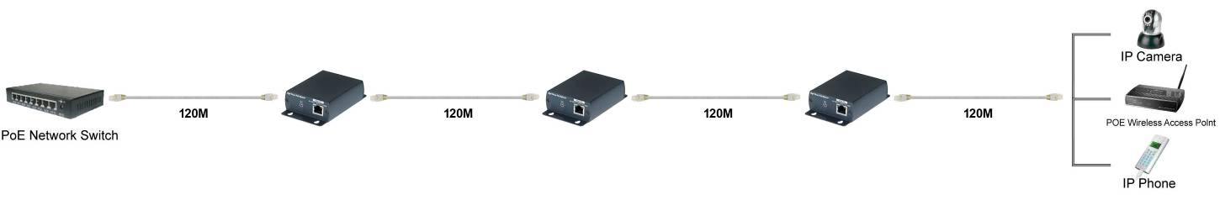

Panel View:

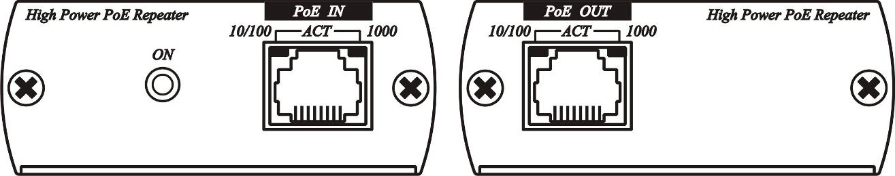

Linking Cable：

Use CAT.5e UTP/STP or CAT.6 UTP cable

LED Indication：

LED (Green) | ON | PSE send power
LED (Green) | OFF | PSE non-power
RJ45 (Yellow) | ON | 1000 Mbps link
RJ45 (Yellow) | OFF | 1000 Mbps unlink
RJ45 (Yellow) | FLASH | Activity
RJ45 (Green) | ON | 10/100 Mbps link
RJ45 (Green) | OFF | 10/100 Mbps unlink
RJ45 (Green) | FLASH | Activity

Option Model:
IP06I : High Power POE injector IEEE 802.3at POE standard.
IP06H: 5 Port High Power POE Switch IEEE 802.3at POE standard.

Specification:
ITEM NO. | IP04X
Power & Data Input/Output | RJ45
Data Link | Pin 1/2，3/6，4/5，7/8
Power Link | Pin 1/2 (+)，3/6 (-) End-Span
Transmission Range | 3 pieces repeater up to 480 Meters
LED Indication | Power: Green, Data link: Yellow/Green
POE | IEEE 802.3af Standard, 48V、12.95W
Power Consumption | Non-load 1.62W (30mA)，1.89W (35mA) @ 10Mbps，2.16W (40mA) @ 100/1000Mbps
Temperature | Operation: 0 to 55°C, Storage: -20 TO 85°C, Humidity: up to 95%
Dimensions mm | 67×110×27 mm
Weight g | 180g

Rev.A

